Recommendation on Making
Broadband Affordable in Asia

Abu Saeed Khan
Senior Policy Fellow, LIRNEasia
January 2014

Please direct all correspondence to: abu[at]lirneasia[dot]net

Table of Contents
1. Background 3
2. Submarine cables 5
2.1 Transatlantic - U.S.A. to Europe: 5
2.2 Europe demystifies infrastructure: 6
2.3 Transpacific route between U.S.A. and Asia: 7
2.3.1 Singapore: 9
2.3.2: Hong Kong: 9
3. Internet gets centralized in Asia 11
3.1 The irony of India: 14
4. Asia’s fragile Internet infrastructure 17
4.1 Frequency and cost: 17
4.2 Natural disasters: 17
4.3 Sabotaging the submarine cable networks: 17
4.4 Bypassing the “choke points” of undersea networks: 18
4.5 Groundbreaking EPEG: 19
5. Why Asian Highway 21
5.1 Overview: 21
5.2 Technology blends submarine and terrestrial cables: 21
5.3 Huge savings in CAPEX and OPEX: 22
5.4 Unlocking the landlocked: 22
5.5 Connecting the “dots” in Pacific: 24
5.6 TASIM – Trans-Eurasian Information Superhighway: 25
7. Consider beyond the highway 26
7.1 Rail and Power infrastructure: 26
7.2 TransTeleCom (TTK), Russia: 26
7.3 RailTel Corporation of India Ltd. 27
7.4 Power Grid Corporation of India Limited (PGCIL) 27
7.5 Asia meets Europe through MEETS: 28
8. Policy recommendations for ITU 29
8.1 Promote open-access optical fiber network along Asian Highway: 29
8.2 Persuade synergy between Asian Highway and TASIM: 29
8.3 Assessing the state of international transmission network: 29
8.4 Assess the cost to build and operate a Eurasian terrestrial network: 29
8.5 Opportunities of using cross-sector telecoms infrastructure: 29
Endnotes 30

1. Background

1.1 Preamble

LIRNEasia is a pro-poor, pro-market think tank working across the Asia Pacific. Our mission is
"Catalyzing policy change through research to improve people’s lives in the emerging Asia Pacific by facilitating their use of hard and soft infrastructures through the use of knowledge, information and technology.

The availability and affordability of high speed, reliable broadband services is vital to the economic development of countries. It is particularly vital for citizens of the emerging economies we work in. Our work has therefore focused on the availability of affordable and reliable band-width at all parts of the broadband value chain. In this report, we focus on our work on international internet bandwidth, a key bottleneck faced by emerging economies. We have been partnering with the United Nations Economic and Social Commission for Asia Pacific (UN-ESCAP) on a possible solution to this problem.

We believe the initiative detailed in this report can form a vital part of ITUs mission to make ubiquitous and affordable broadband networks available across the world.

1.2 Summary

LIRNEasia’s research has detected that median wholesale Internet bandwidth in Asia is more than thrice expensive than Europe. As a result, although 60% of the global population lives in Asia; only 38% of them have access to the Internet while fewer can afford broadband. Unlike North America or Europe, the Asian countries are solely interconnected through submarine cables. The undersea cables are very expensive to deploy and maintain. They are also vulnerable to natural disasters, accidents and suspected sabotage.

Over-reliance on submarine networks, therefore, keeps Asia’s international bandwidth pricier. As a result, it hinders universal access to broadband. LIRNEasia believes a cross-border terrestrial networks, with open access, can bridge Asia’s digital inequality. And “Asian Highway” is the most suitable platform to achieve that goal.

Asian Highway was initiated by ESCAP in 1959 to promote the development of international road transport in the region. This 141,000-kilometers highway network of 32 Eurasian countries spans from Japan to Turkey.

Therefore, LIRNEasia has urged ESCAP to consider the construction of a fiber network along Asian Highway to make broadband sustainably affordable across the developing Asia. Adding redundancy and diversity to submarine cable networks is central to LIRNEasia’s proposal along with following broad objectives:

- Fiber along the Asian Highway also inherently creates a domestic transmission network for every country. Therefore, it will reduce the cost of domestic backhaul, which has been also a barrier to Asian bandwidth markets.

- Open access will be critical to the success of entire initiative. All the carriers’ access to this proposed telecoms infrastructure will drive national broadband initiatives through FTTx, 3G and 4G/LTE. Besides, the Asian carriers will solidify their position in cloud computing, which is increasingly becoming central to broadband.

- Fiber along Asian Highway will cease the landlocked countries’ isolation from the mainstream of Internet. Asian Highway members like Indonesia and Philippines will be greatly benefitted from the reduced costs of IP transit at the major Asian hubs. Ripple effect of competition will immediately influence the satellite carriers and the small island developing states (SIDS) will have universal access to broadband.

As a result, ESCAP has decided to conduct in-depth studies on broadband infrastructure and connectivity across Asia. In early 2013, LIRNEasia has entered into a partnership with ESCAP to review and strengthen the latter’s policy recommendations. LIRNEasia is also assisting the ESCAP secretariat in developing well targeted and policy relevant briefs that lead to actionable recommendations aimed at senior policy makers.

ESCAP has been fostering the Asian Highway. All the members of this multi-country highway network are also by default the member states of the ITU. Therefore, LIRNEasia underscores the importance of partnership between ESCAP and ITU to materialize the concept of “Asia-Pacific Information Superhighway”. Because, this initiative truly captures the Broadband Commission’s spirit of “Policy Recommendations to Maximize the Impact of Broadband.”

This document is the result of LIRNEasia’s engagement with ESCAP. It intends to highlight the problems pertaining to cross-border connectivity being the major cause of digital divide. Most importantly, it highlights the diminished functional differences between terrestrial and submarine cable networks in long-haul telecommunication applications.

2. Submarine cables
2.1 Transatlantic - U.S.A. to Europe: First generation optical fiber, with unprecedented speed and capacity, had immediately started replacing the undersea networks’ coaxial cables and microwave links in terrestrial transmission systems. Developed economies were the early adopters due to high costs of optical fiber and ancillaries. Like any groundbreaking technology, knowhow of commissioning the optical fiber system also remained in the exclusive domain of the developed countries.

According to Terabit Consulting, during 1987 to 2012, more than 1 million route-kilometers of submarine cables were deployed across the Atlantic to link United States with Western Europe. According to another estimate, carriers have deployed some 19 million miles (30.6 million km.) of optical fiber cables across America until 2011.

Currently seven submarine cable systems are functioning between North America and Europe (Table 1). They are owned by six entities: Apollo SCS Ltd. (a joint venture between Vodafone and Alcatel-Lucent), Level 3 (formerly Global Crossing), Hibernia Networks (owned by Columbia Ventures Corporation and Constellation Ventures Partners), Reliance Globalcom, Tata Communications, and the TAT-14 consortium.

Table 1: Existing Transaltantic (U.S.A. to Europe) Cable Systems
Submarine Network Name | RFS Year | Length (km) | Lit Capacity (Gbps) | Max Capacity (Gbps) | Owner(s)
Apollo | 2003 | 13,000 | 3,650 | 38,400 | Vodafone/Alcatel-Lucent
Atlantic Crossing-1 (AC-1) | 1998 | 14,301 | 1,760 | 4,480 | Level 3
Atlantis-2 | 2000 | 8,500 | 40 | 160 | Consortium
Columbus-3 | 1999 | 9,833 | 160 | 320 | Consortium
FLAG Atlantic-1 (FA-1) | 2001 | 14,500 | 2,840 | 26,400 | Reliance Globalcom
Hibernia Atlantic | 2001 | 12,200 | 2,950 | 15,360 | Columbia Ventures Corp.
TAT-14 | 2001 | 15,295 | 1,870 | 8,960 | Consortium
Tata TGN-Atlantic | 2001 | 13,000 | 2,810 | 20,480 | Tata Communications
Yellow | 2000 | 7,001 | 3,120 | 11,200 | Level 3
Source: TeleGeography and Terabit Consulting.

The transatlantic route is generally known as “wholesale” market. Carriers lease capacity from network operators, as opposed to directly investing in infrastructure. In the late-1990s, hundreds of pairs of optical fibers were also deployed in metropolitan areas of both the continents, making point-to-point connectivity both economical and practical. The dot-com bubble burst in the early-2000s made many submarine cable operators bankrupt. New investors have acquired those networks at insignificant prices. It unleashed a freefall of prices up to 75% per year and the “dumping” of bandwidth became business as usual.

In the same decade, new industries emerged offering data center and content delivery services that further streamlined international connectivity for both operators and end-users. By the mid-2000s transatlantic bandwidth became so cheap that sometimes it dropped below the construction cost. End-to-end services between North America and Europe were efficiently and competitively managed, to the point where even small and medium enterprises could be characterized as viable bandwidth clientele.

Meanwhile, deregulation and market liberalization in Europe has drawn massive investments from U.S.A. They deployed 6 million kilometers of fibers across the continent in 1999 and added more than 10 million kilometers fibers until 2002. The number of pan-European-based metropolitan area network (MAN) was also increased from just one in 1993 to 35 in 1999. Between 1998 and 2002, 90% of the backbone fiber was installed by the new entrants in European long-haul markets.

The long-haul networks typically had 96 fibers, while 144-fiber- cables were installed in the MANs. All of these networks were equipped with dense wavelength-division multiplexing (DWDM) systems, which was a revolutionary feature at that time. U.S.A. and Europe have been bolstering their underground and undersea fiber networks to maintain competitive edge in the global economy. According to Terabit Consulting, lit transatlantic capacity was 19.8 terabits per second (Tbps) by the end of 2012 with 27% compound annual growth rate during the preceding five years.

2.2 Europe demystifies infrastructure: Cross-border terrestrial connectivity is widely perceived to be less effective than submarine cables. Higher broadband indicators of landlocked OECD countries, solely depending on terrestrial fiber networks, address this fallacy. Six out of the 34 OECD countries are landlocked and they are all connected through terrestrial links. Yet, the formers’ fixed wired broadband penetration is better than many countries having the world’s highest numbers of submarine cables and Internet bandwidth (Figure 1).

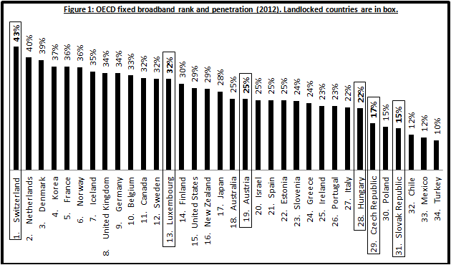

Switzerland has topped among the OECD countries in fixed broadband ranking. It is far ahead of France (5), United Kingdom (8), Germany (9), Canada (11) and Sweden (12). Landlocked Luxembourg (13) and Austria (19) have also outranked United States (15), Australia (18), Greece (24), Portugal (26) and Italy (27) in fixed broadband penetration.

Landlocked OECD countries are also ahead in fixed and mobile wireless broadband penetration (Figure 2). Luxembourg (9), Switzerland (17), Austria (18) and the Czech Republic (20) have outranked Spain (21), France (22), Canada (23), Greece (24), Germany (25), Portugal (26), Italy (28) and Turkey (32).

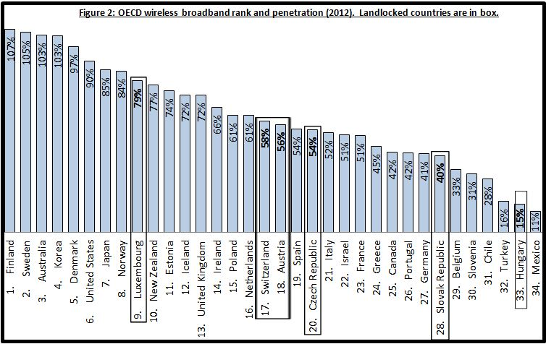

Data centers are simultaneously the factories and warehouses of Internet. And a good number of OECD landlocked countries have emerged as the new generation of IP transit wholesalers and data center providers. Diverse cross-border connectivity coupled with highly reliable world class data centers is central to the rise of this new leadership.

Cushman & Wakefield, Hurleypalmerflatt and Source8 have ranked Switzerland (11) far ahead of South Korea (13), France (14), Singapore (15) and Japan (26). Another landlocked country, The Czech Republic (22), has also outranked Australia (23), Russia (24), China (25), Japan (26) and India (29) in terms of data center reliability.

Their risks are mostly related to physical, economic and social issues. Other factors, however, such as high energy costs, poor international internet bandwidth and protectionist legislation are also risks that need to be taken into account. And by virtue of their dramatic emergence, Europe is now challenging the historical leadership if United States in global IP transit wholesale market.

2.3 Transpacific route between U.S.A. and Asia: Sparsely located landing points at prime Asian destinations and longer intercontinental distances have made the construction of transpacific submarine cable systems an expensive affair. Cable projects connecting the west coast of U.S.A. with Japan, China, Hong Kong SAR, Singapore and South Korea are, therefore, less attractive to the institutional investors. That’s why, unlike the transatlantic markets, Asian long distance carriers have been the historical investors in transpacific submarine cable systems. Investment in new transpacific systems has been, however, more consistent than in the transatlantic market. New transpacific cables began entering into service less than six years after completion of the last cable from the “dot-com” investment boom (Table 2).

Table 2: Existing Transpacific (U.S.A. to Asia) Cable Systems
Submarine Network Name | RFS Year | Length (km) | Lit Capacity (Gbps) | Max Capacity (Gbps) | Owner
Asia-America Gateway (AAG) Cable System | 2009 | 20,000 | 1,880 | 6,000 | Consortium
China-U.S. Cable Network (CHUS) | 2000 | 30,476 | 160 | 160 | Consortium
Japan-U.S. Cable Network (JUS) | 2001 | 22,682 | 4,000 | 9,000 | Consortium
Pacific Crossing-1 (PC-1) | 1999 | 20,900 | 2,060 | 3,360 | NTT
Tata TGN-Pacific | 2002 | 22,300 | 3,710 | 15,360 | Tata Comm
Trans-Pacific Express (TPE) Cable System | 2008 | 17,000 | 1,600 | 3,200 | Consortium
Unity/EAC-Pacific | 2010 | 9,620 | 3,500 | 12,000 | Consortium
Source: TeleGeography and Terabit Consulting.

South Korea (98%) and Japan (94%) lead the world in terms of FTTx coverage and LTE penetration. Meanwhile, Singapore (2) has outranked South Korea (11) while Hong Kong (14) is ahead of Japan (21) in World Economic Forum’s Global Network Readiness Index. It demonstrates the digital might of these Asian powers in global stage.

The growth of Chinese Internet and telecommunications markets will primarily drive transpacific and Asian submarine markets. As of June 2013, Chinese international bandwidth exceeds 6 Tbps, with more than 2.4 Tbps directed toward the United States. International bandwidth of China has also exceeded Japan’s 4.3 Tbps at that time.

Under the 12th Five-Year Plan, the Chinese government will invest 2 trillion Yuan ($323 billion) to comprehensively improve its broadband infrastructure by 2020. With the aim of taking the nearly entire population online, the government has planned to boost the average broadband speed in cities to 20 Mbps by 2015. Yet it will be less than what the Internet users in Hong Kong and Singapore currently enjoy.

In rural China, where Internet penetration is very low, broadband speeds would hit 4 Mbps by 2015. China's broadband strategy will ensure that the number of 3G and LTE users will increase by four fold - to 1.2 billion by 2020.

Singapore and Hong Kong are historically reputed to be Asia’s hubs of global trade and commerce. They have reformed respective policy and positioned themselves as regional hubs of wholesale Internet bandwidth.

2.3.1 Singapore: Singapore liberalized its telecom sector in 2000 and reformed its regulatory framework as well. Establishing a “Code of Practice for Competition in the
Provision of Telecommunication Services” was one of the most important steps it took. Singapore’s Info-Communications Development Authority (IDA) determined that the dominant carrier, SingTel, should allow collocation at its submarine cable landing stations. This requirement was incorporated into the mandated Reference Interconnection Offer (RIO) that SingTel was instructed to prepare, containing cost-based rates for collocation. IDA has, however, left connection services to be negotiated commercially between SingTel and its competitors.

The regulator also kept receiving feedback, on the impact of its newly introduced framework, from industry. Two years later, in 2002, IDA had added connection services to the mandated offerings included (again, at cost-based rates) in SingTel’s RIO. In 2004, it further allowed the operators to access the capacity that is owned or leased on a long-term basis on any submarine cable at the submarine cable landing station. IDA also gave operators more flexibility in accessing backhaul and transit services.

IDA has also streamlined the cable landing authorization procedures by setting up a “one-stop shop”. It relieved the submarine cable operators seeking to land their cables in Singapore. Earlier, they were to obtain approval from the Maritime and Port Authority for the wet segment while the Urban Redevelopment Authority and the Singapore Land Authority approved the dry segment of the inward cable systems. IDA has greatly shrunk such cumbersome approval process, which used to take months.

2.3.2: Hong Kong: Hong Kong has also comprehensively overhauled its regulation regarding international communication infrastructure. In his Policy Agenda during 2009-10, the Chief Executive of Hong Kong SAR has directed to review the procedure for landing submarine cables in the territory. He also ordered to make the administrative process simpler and speedier for interested parties to install new submarine cables with or without affiliated data centers.

Accordingly in 2009, the Office of the Communications Authority (OFCA) has commissioned an independent consultant to detect the bottlenecks at the landing of new submarine cables in Hong Kong. At that time, the applicants had to approach various offices namely the Lands Department, Environmental Protection Department, Marine Department, Agricultural Fisheries and Conservation Department, Home Affairs Department and Leisure and Cultural Services Department in Hong Kong.

The consultant has identified the need to increase the transparency of the application processes with a view to promote understanding of the application processes. In this regard, OFCA has launched a dedicated web page to provide the industry with the relevant information. The regulator also became the single-point-of-clearance for any new submarine cable to land in Hong Kong.

After extensive consultation with the industry, OFCA has also set aside nine plots of land at land at the oceanfront Chung Hom Kok Teleport site for submarine cable landing station (SCLS) and satellite earth station. To facilitate the industry to gather information on the available lots and source sites for new SCLS, the relevant information were included in the web page of OFCA.

As a result, new entrants can collaboratively build and share their cable stations. If a new cable wants to land in Hong Kong, it can either land in one of the existing cable stations or get the land set aside by OFCA to build their own cable station. Hong Kong has an open licensing regime so there is no limit to the number of new cable licenses that can be issued. In addition, OFCA also provides help in buying backhaul at reasonable costs from existing providers or will provide licenses for cables to build their own backhaul.

3. Internet gets centralized in Asia
Regulatory reforms have allured international submarine cable operators to Singapore and Hong Kong. Ease of doing business, rule of law and policy certainty has given them the global fame of preferred data center sites as well. Diverse international connectivity and the world’s leading Internet companies’ presence have eventually made Singapore and Hong Kong the regional hubs of hosting contents and trading Internet bandwidth (IP transit).

The IP transit prices vary across the core markets of East Asia. And the Asian carriers are less transparent than their western counterpart in terms of price disclosure. TeleGeography alleges that fewer carriers report the prices of IP transit in Asia than in Europe or North America, particularly for high capacity ports, rendering median price trends more vulnerable to changes in carrier research participation over time.

The IP transit prices have been sharply declining worldwide. The median 10 GigE prices in Hong Kong have, however, remained 3 to 5 times the price of a GigE port in London over the past 3 years (Figure 3). According to TeleGeography, Hong Kong’s $7.00 per Mbps median price for 10 GigE is more than four times that of comparable ports in Europe or North America. The lowest price cited for a full 10 GigE port in Hong Kong, $2.95 per Mbps, is still approximately twice the price seen in the U.S. and Europe.

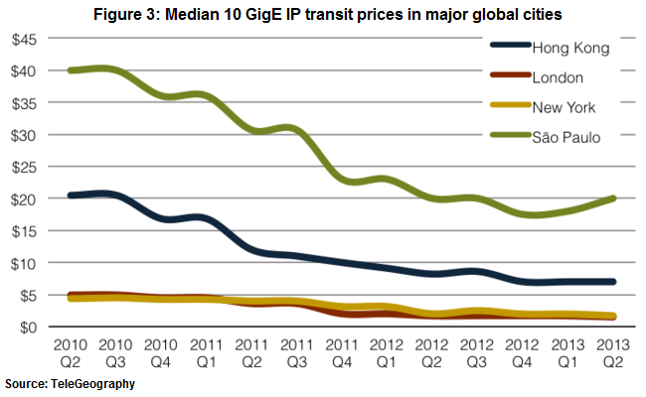
TeleGeography is explicit about the IP transit being so pricier in Asia, “This difference is due in large part to the relatively high cost of transport in Asia. A major proportion of Hong Kong’s Internet traffic is international, and this traffic must transit international gateways and undersea cables. The cost of Asian submarine cable capacity is significantly higher than the cost of the terrestrial fiber used by carriers in North America and Europe, and this cost difference is reflected in IP transit prices.”

Median GigE prices in Manila decreased 17% during 2012 and 2013 and 32% compounded annually since 2010. Prices in Jakarta dropped 22% over the past year and 26% over the past three years. Prices for 10 GigE ports in Mumbai are below $20 per Mbps per month. The prices in Bangkok, Jakarta, and Kuala Lumpur have all fallen below $15 (Figure 4).

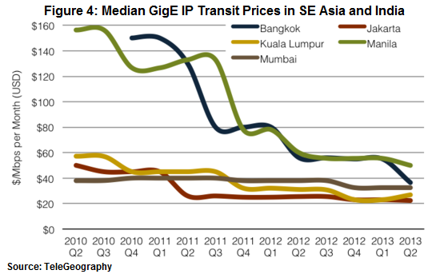

Despite being located in the world’s largest landmass, the developing nations of South Asia and Southeast Asia are primarily interconnected through submarine cables. Such overreliance on undersea telecom infrastructure has made the wholesale Internet bandwidth prohibitive in this region (Table 1). It has created two unintended, yet unavoidable, bottlenecks (Singapore and Hong Kong) in the regional wholesale supply chain of Internet bandwidth.

Table 3: Median Asian IP Transit Prices per Mbps (GigE)
 | Q2 2010 | Q2 2011 | Q2 2012 | Q2 2013 | 2012-13 | CAGR 10~13
Developed Asia
Hong Kong | $28.00 | $22.00 | $16.00 | $16.49 | 3% | -16%
Seoul | $49.16 | $37.00 | $25.00 | $20.00 | -20% | -26%
Singapore | $39.00 | $31.00 | $14.40 | $13.51 | -6% | -30%
Taipei | $43.50 | $39.33 | $25.00 | $21.34 | -15% | -21%
Tokyo | $31.76 | $30.01 | $20.00 | $18.00 | -10% | -17%
Developing Asia
Jakarta | $50.00 | $26.00 | $25.50 | $20.00 | -22% | -26%
Kuala Lumpur | $57.00 | $45.03 | $31.08 | $26.85 | -14% | -22%
Manila | $156.23 | $132.97 | $60.00 | $49.98 | -17% | -32%
Mumbai | $38.09 | $40.00 | $38.00 | $38.00 | 0% | 0%
Source: TeleGeography. Notes: Monthly US$/Mbps prices for a full-port commitment, excluding local access and installation fees. Gigabit Ethernet (GigE) = 1,000 Mbps.

Developing Asian nations procure wholesale Internet bandwidth mostly from Singapore and Hong Kong at price 11-times that of Europe. Subsequently, the bandwidth becomes pricier once it reaches the international gateway at the purchaser’s country. The cost of domestic backhaul and other charges get accumulated before delivering the bandwidth through various retail outlets like mobile and fixed broadband networks.

The consumers of developing Asia are punished with additional costs when they seek to access the international Internet contents. The IP transit in poorer markets like Myanmar and Lao PDR costing more than 10-times that of Singapore is one such example. As a result, the broadband consumers in Cambodia, Lao PDR and Myanmar pay equivalent to 48.7%, 27.4%, and 132.8% of respective per-capita GDP for 1 Mbps connection. Only Singapore and Thailand offers most affordable broadband (Figure 5).

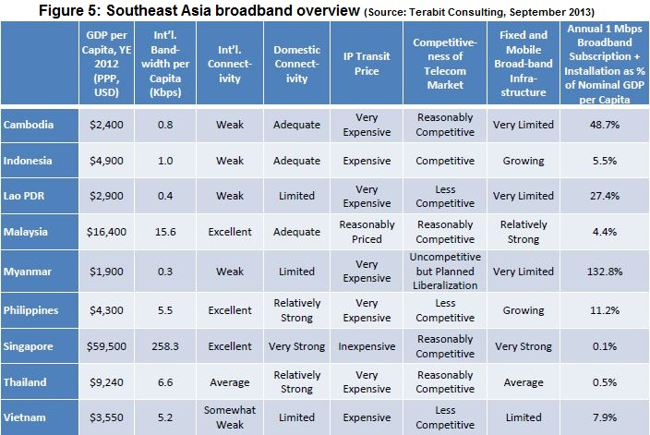

Aggregation of international Internet bandwidth in Singapore and Hong Kong “has developed in a hub-and-spoke configuration around these two hubs, although telecommunications carriers and other investors of means have constructed their own direct interregional fiber infrastructure wherever possible.”

Singapore and Hong Kong have positioned themselves as regional hubs through consistently adjusting respective policy pertaining to the entire broadband supply chain. In contrast, their regional neighbors have heavily invested in intra-Asia submarine cable systems and rudimentary cross-border bilateral terrestrial fiber optic deployments. Terabit Consulting has identified 13 of such trans-border links, often owned by the dominant carriers from each side of the border.

Lack of open access in these cables across the borders hinder competition and most of such links operate at very low capacity – usually 10 Gbps or less. Whereas, the entire international bandwidth for the ASEAN countries (Except Brunei) was 3,420 Gbps in 2012. The bilateral and point-to-point nature of these links are further impacted by the region’s widely varied bandwidth prices. It often allows dominant operators in wealthier nations to exploit with access to their own submarine cable gateway.

Noble initiative of regional cross-border optical fiber connectivity under Greater Mekong Sub-region (GMS) project is another victim of the state-owned incumbents’ exclusive ownership. As a result, Myanmar is unable to take any advantage from GMS network when its only submarine cable link experiences outage. Myanmar’s Internet connectivity routes through six international carriers, which is being considered as “a decent level of provider diversity.” The terrestrial connection to its only landing station of SEA-ME-WE3 submarine cable was snapped on July 22, 2013. It had immediately isolated the country from rest of the world. It proves that Myanmar’s none of the six International counterpart uses the GMS network. This occurrence demonstrates the futility of bilateral telecom infrastructure initiatives at regional level.

3.1 The irony of India: Annual turnover of India’s IT and IT-enabled services is US$ 110 billion. According to TeleGeography, only 13.8 million Indian broadband users (6% penetration) were connected with 888,859 Mbps international Internet bandwidth in 2012. It also said that 156 million Chinese broadband users (39% penetration) were plugged with 4,210,155 Mbps bandwidth at the same time. Leading Indian researchers (Gumaste et al) have detected international and domestic connectivity among other issues hindering the country’s broadband growth.

Bandwidth costs in India are among the highest across the globe, primarily due to limited lit-up submarine fiber connectivity. This makes it expensive to fetch overseas content. Ironically, up to 80+% of the content accessed in Indian networks resides overseas, further contributing to the cost of bandwidth. In addition, operators use submarine cables as choking points to thwart competition from local providers, leading to an artificial scarcity of bandwidth.

The regulatory authorities in India need to control malpractice of ISPs, especially in terms of network peering. We outlined specific instances whereby peering between domestic operators failed, resulting in domestic traffic being routed internationally, only to come back into the country. The regulatory authority has been unable to enforce the good quality of service (QoS) usually associated with broadband services.

The top five countries for broadband penetration have had a dual pronged approach with reliance on both fiber as well as wireless in the last mile. Indian providers in contrast have been focusing only on wireless technologies, which cannot scale to meet the broadband requirements of densely populated cities (due to spectrum limitations). This approach reduces the chances of broadband penetration on account of the inability to offer good services (spectrum limitations) and results in lower return on investment (ROI).

It is noteworthy to mention that all submarine cables connecting the Far East with Europe and Africa transit at India. It has made 12 submarine cables (six owned by consortiums and six privately-owned) hopping into 10 cable landing stations (CLS) at the Indian seashore. Voice and data traffic of 27 international long distance operators (ILDO) are processed through these cable landing facilities. Four (Tata, Airtel, Reliance and BSNL) out of the 27 ILDOs own respective CLS in India.

The ILDOs, who don’t own CLS, told Telecommunication Regulatory Authority of India (TRAI) that Tata Communication and Bharti Airtel together enjoy a 93% market share. They have alleged that although average cost of submarine cable bandwidth has dropped significantly, the average Access Facilitation Charges (AFC) at the Indian CLS remained unchanged for four years (until 2012). They blamed the AFC at CLS being the significant portion of the total bandwidth charges paid by the Indian consumers.

In March 2012, TRAI has invited a public consultation with disturbing revelations. Tata annually charges US$628,100 AFC for an STM64 at its Mumbai CLS while Bharti Airtel charges US$450,600 at its Chennai CLS. The same bandwidth, however, costs less than US$700 per annum at Tuas CLS in Singapore. Therefore, Tata’s and Airtel’s AFC in India is respectively 897-times and 644-times expensive than Singapore’s.

On December 21, 2012 - the TRAI has asked India’s submarine cable majors to charge $11,444 for each STM64 circuit at any CLS, effective from January 1, 2013. Tata Communication has, however, challenged the regulatory decree and Madras High Court has stayed the TRAI’s order. That possibly indicates why the London-Mumbai circuit is so expensive than London-Singapore (Figure 6).

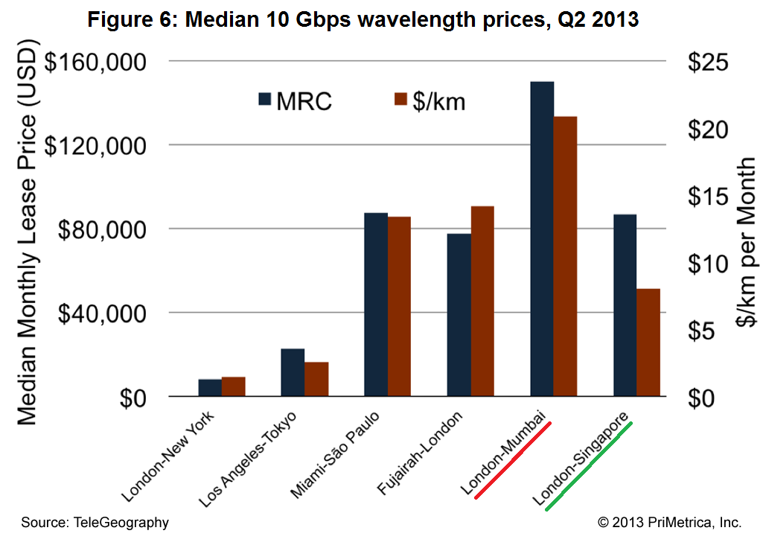

The Indian example of the incumbents’ resistance to reform the international gateway is pervasive across the developing Asia. Such trend is largely instrumental to the widening gap of Asia’s IP transit prices, as shown in Table 1 above.

Policymakers of developing economies are often being deceived by sectoral “growth rate” while the actual achievement remains unnoticed. The Asian economies’ 5-year growth rate of international Internet bandwidth is, indeed, highly impressive. The real bandwidth addition during this period is, however, embarrassingly minimal (Figure 7).

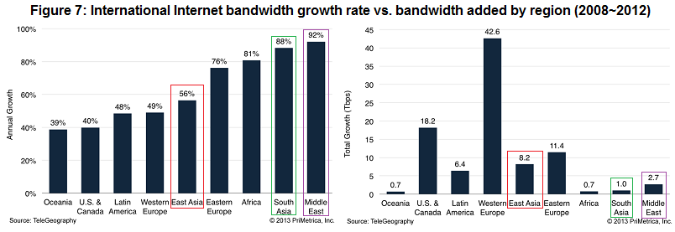

Unlike Singapore and Hong Kong, the Indian regulator may yet to succeed in reforming the landing of submarine cables. Its initiative to remove the tariff barriers from submarine cable landing stations has been catching dust in the court of law. TRAI relentlessly persuading the agenda of making broadband affordable, however, merits be acknowledged and praised.

4. Asia’s fragile Internet infrastructure

4.1 Frequency and cost: The Internet is a robust virtual infrastructure comprised of tens of thousands of communicating enterprises, each seeking to maximize profit according to local rules and business conditions. Fragile infrastructure, notably the submarine cables and terrestrial fiber networks, keeps the flow of Internet traffic worldwide.

A submarine cable snaps in every three days while a terrestrial cable gets severed in every 30 minutes somewhere in the world. The global economy counts annual loss of US$26.5 billion due to such disruptions. Countries having required diversity of connectivity across the sea as well as overland, survive the outage of Internet.

4.2 Natural disasters: Asia was stunned by an earthquake near Taiwan on December 26, 2006 that had devastated the Internet, voice and data services in India, China, Hong Kong, Singapore, Taiwan and the Philippines. Day-to-day banking, airline bookings and email were either stopped or delayed. There were 21 faults in 9 submarine cables and it took 11 cable repair ships 49 days to fix the damage.

Typhoon Morakot followed by earthquake in Taiwan on August 7, 2009 had severed 10 submarine cables. Up to 90% voice and data traffic was impacted across Japan, Taiwan, China, India and South East Asia. On March 4, 2010 another earthquake in Taiwan has snapped SEA-ME-WE 3, APCN2, CUCN, FLAG and FNAL submarine cables.

On March 11, 2011 – Japan was struck by the devastating earthquake followed by a catastrophic tsunami. Its Internet system, however, remained functional although two major submarine cables were severed. Because, Japan took the lessons from previous earthquakes and kept comprehensively bolstering its transmission network. Following assessment of Renesys deserves the policymakers’ attention:

"The engineers who built Japan’s Internet created a dense web of domestic and international connectivity that is among the richest and most diverse on earth, as befits a critical gateway for global connectivity in and out of East Asia. At this point, it looks like their work may have allowed the Internet to do what it does best: route around catastrophic damage and keep the packets flowing, despite terrible chaos and uncertainty."

Financial capacity of developing Asia cannot and should not be compared to Japan’s. Yet, the fact remains that regional connectivity was impacted after Japan’s earthquake due to Southeast Asia’s lack of diversity at international front.

4.3 Sabotaging the submarine cable networks: Between January 23, 2008 to February 4, 2008 – six submarine cables were snapped in a row in 12 days across the Mediterranean Sea, Red Sea and the Strait of Malacca. ITU’s the then Director Sami Al Basheer Al Morshid raised the red flag, “We do not want to preempt the results of ongoing investigations, but we do not rule out that a deliberate act of sabotage caused the damage to the undersea cables over two weeks ago.”

On March 27, 2013 Egyptian authorities have arrested three divers trying to cut through SEA-ME-WE4 undersea cable. The men were caught on a fishing boat just off the port city of Alexandria. It is the world’s first confirmed attempted sabotage on a submarine cable system. It may be noted that three other major Europe-to-Asia cables, I-Me-We, EIG and TE North were snapped across the Egyptian coast during this time. Such simultaneous outages have widely disrupted telecommunication services across the Middle East and Asia.

4.4 Bypassing the “choke points” of undersea networks: Asian submarine cable networks encounter five major geographic bottlenecks. Too many submarine cables passing through a narrow maritime passage makes them vulnerable to accidents followed by mass outage, as discussed above. Such choke points are:

- The Strait of Luzon between the Philippines and Taiwan.
- The Strait of Malacca between Indonesia and Malaysia.
- The Strait of Hormuz between Iran and United Arab Emirates.
- The Suez Canal in Egypt as well as the Red Sea region.
- The Strait of Sicily in the Italian maritime zone.

On February 19, 2013 – a consortium of Japan, the Philippines, Hong Kong, Malaysia, and Singapore has commissioned the Asia Submarine-cable Express (ASE) system bypassing the Strait of Luzon. The carriers have also started bypassing the increasingly risky Suez Canal route to Europe sing land borders. Asia historically has more international Internet capacity connected to the U.S. and Canada than to any other region. However, this proportion is falling steadily as the Asian carriers are less dependent on the U.S. for connectivity.

In 2013, nearly 40% of Asia’s 19.9 Tbps of international Internet bandwidth was connected to the U.S. and Canada, down from 48% in 2009. Similarly, while trans-Pacific capacity increased 32% in 2013, this was surpassed by both intra-Asian capacity growth of 44%, and capacity growth on routes between Asia and Europe of 42%.

The decline in the share of Asian international Internet bandwidth connected to the U.S. and Canada has been largely picked up by Europe. As transport prices on the Europe-Asia route have declined due to the introduction of multiple new submarine cables, the share of Asian Internet bandwidth connected to Europe has increased from 21% in 2009, to 28% in 2013.

Historically, the terrestrial links between Europe and East Asia is provided via two trans-Russian networks operated by Rostelecom and TTK. Their networks are linked with Chinese carriers to provide direct connectivity between European and Chinese cities. TTK’s terrestrial route is dubbed the Eurasia Highway. Rostelecom’s terrestrial system on the route is known as the Transit Europe-Asia (TEA) network. Rostelecom and China Telecom also have connections between their networks that traverse Kazahkstan and Mongolia.

4.5 Groundbreaking EPEG: According to TeleGeography, the terrestrial Europe-Asia link follows a more direct route between the continents than submarine cables, resulting in lower latency. After monitoring the performance of Europe Persia Express Gateway (EPEG) system, Renesys Corp. has officially announced, “EPEG is now the Internet’s fastest path between the Gulf and Europe, shaving at least ten percent off the best submarine cable round trip time from Dubai to Frankfurt.”

EPEG links Germany to Oman via Russia and Iran, was launched in January 2013. The system offers an initial lit capacity of 540 Gbps. Jim Cowie, Chief Technology Officer of Renesys Corp. wrote in his official blog:

If you’d told me five years ago that we would one day see Iranian and Russian terrestrial Internet transit serving the countries of the Indian Ocean, from Pakistan to East Africa, I wouldn’t have believed it.

Today, I’m a believer. We’ve seen all kinds of strategies emerge in the wake of the SMW4 cuts, from Telecom Egypt transit (as far away as Afghanistan), to Israeli transit, to Iraqi transit, to Syrian transit through a war zone.

In the hands of Omantel, EPEG is the first solution that appears to be delivering globally visible terrestrial routes to a diverse set of regional providers.

It remains to be seen whether an Internet path through Iran and the Russian Caucasus region will have the kind of stability that enterprises require. But frankly, compared to the submarine cable competition, they’re already looking pretty good.

On April 30, 2013 – a consortium of carriers from Malaysia, UK, Oman, UAE, India and Sri Lanka signed has announced the construction of Bay of Bengal Gateway (BBG) submarine cable system to link Asia with Europe. Although originates from Singapore, the BBG cable terrestrially traverses across Malaysia and terminates at Penang to avoid the Strait of Malacca. Then it proceeds westwards across the seabed to hop first at India and then at Sri Lanka before terminating at Bakara of Oman. Subsequently, to bypass the Red Sea and Egypt, the BBG cable gets linked with EPEG network in Iran.

The above developments demonstrate the Asian carriers’ desperation for a safer passage to Europe. Because, Europe has emerged as the global hub of Internet. Middle East’s Internet connectivity with Europe has sharply grown from 51% to 85% during 2003~2013.

Less than 6% of South Asian capacity was connected to Europe in 2003 while it is over 46% in 2013. Europe now accounts for 94% of international Internet bandwidth connected to North Africa, up from 61% ten years ago. Sub-Saharan Africa’s 72% of bandwidth is now connected to Europe, up from 39% a decade ago.

Meanwhile, Gulf Bridge International has activated the “GBI North Route” in February 2013. It provides terrestrial connectivity from the company’s submarine cable station in Iraq to Europe via Turkey. The desire for diverse routes that avoid Egypt has led to the creation of several other terrestrial options between the Middle East and Europe (Figure 8).

The Jeddah-Amman-Damascus-Istanbul (JADI) network links Saudi Arabia and Turkey via Jordan and Syria. JADI began service in July 2010 with 200 Gbps of lit capacity. The system is reportedly inactive due to the ongoing civil war in Syria. The conflict in Syria has also delayed the completion of the Regional Cable Network (RCN). RCN, while similar to JADI, will be considerably longer, from Turkey to the UAE via Jordan, Syria, and Saudi Arabia.

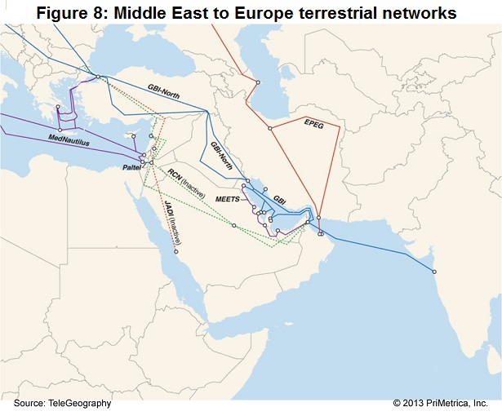

This trend of shifting the gravity from submarine cable to terrestrial links reinforces the idea of deploying a Europe-bound pan-Asian terrestrial optical fiber network. And UNESCAP, which fosters the Asian Highway, should be actively instrumental in securing the right-of-way for this terrestrial network’s deployment.

5. Why Asian Highway

5.1 Overview: The Asian Highway is a road communication platform of 32 Asian governments. It spans 141,000 kilometers from Japan to Turkey, seamlessly linking Asia with Europe. It was initiated in 1959 with the objective of promoting the development of international road transport in the region. The UNESCAP and the Asian Development Bank have been driving this transcontinental transport infrastructure project (Table 4).

Table 4:
Each country’s share in Asian Highway (Countries in alphabetical order)
Country | Length (km) | Country | Length (km)
- Afghanistan* | 4,247 | - Malaysia | 1,595
- Armenia | 966 | - Mongolia* | 4,286
- Azerbaijan | 1,462 | - Myanmar | 3,003
- Bangladesh | 1,768 | - Nepal* | 1,314
- Bhutan* | 167 | - Pakistan | 5,377
- Cambodia | 1,335 | - Philippines | 3,517
- China | 26,181 | - South Korea | 907
- DPR Korea | 1,462 | - Russia | 17,046
- Georgia | 1,101 | - Singapore | 19
- India | 11,650 | - Sri Lanka | 650
- Indonesia | 3,970 | - Tajikistan* | 1,925
- Iran | 11,153 | - Thailand | 5,110
- Japan | 1,111 | - Turkey | 5,245
- Kazakhstan* | 12,856 | - Turkmenistan* | 2,204
- Kyrgyzstan* | 1,695 | - Uzbekistan* | 2,966
- Lao PDR* | 2,317 | - Viet Nam | 2,631
Source: ESCAP *Landlocked developing country (LLDC)

Optical fiber along the Asian Highway will inherently create a domestic transmission network too. Therefore, it will reduce the cost of domestic backhaul, which has been blocking the growth of Asian bandwidth markets. Asian cities and townships will house data centers offering competitive Internet bandwidth.

5.2 Technology blends submarine and terrestrial cables: National highways are the preferred right-of-way to deploy optical fiber transmission backbone. And the Asian Highway is a meshed transcontinental road network too. Therefore, a meshed DWDM fiber network with 100 Gbps capacity will be the ideal option for redundancy to the Asian submarine cable networks. It will effectively eliminate the risks of outage from accidents, sabotage or natural disasters.

Moreover, the latest 100G transmission technology called ROADM (Reconfigurable Optical Add-drop Multiplexer) is getting pervasive. As a result the data centers, located far away from seashore, have emerged as the virtual submarine cable landing stations at the city centers. Such dramatic development has effectively blurred the functional differences between submarine and terrestrial optical fiber networks.

The days of a separate optical transport layer are forever gone, as convergence has made the concept of implementing networks in discrete layers obsolete. And, network intelligence through software is more important than ever. Networks have to be open to third-party software control, and they have to be programmable and automated to respond to requests made by those apps.

5.3 Huge savings in CAPEX and OPEX: Korea Telecom (KT) has estimated that the cost of materials for terrestrial and submarine cable is US$13,800 and $45,000 per kilometer respectively in South Korea. And the cost of building terrestrial and submarine networks is $58,000 and $135,000 per kilometer respectively. KT has also found that it takes maximum one day to repair the fault of a terrestrial link costing $5,000 while repairing a submarine cable costs $500,000 and may take around 20 days.

The above estimates of KT are far higher than the developing Asia’s standard. Yet it the differences in various component strongly suggest huge financial advantage of building and maintaining the terrestrial optical fiber networks.

The Asian countries have required human capacity to deploy, maintain and operate the long-haul terrestrial fiber transmission networks. The investments in such networks get offset by the innovative solutions, longer operating life and lesser operating costs. It will boost the Asian carriers’ competitiveness, as they will be relieved from investing in short-haul and medium-haul undersea cables. They will be able to undertake numerous long-haul submarine cable projects across the Pacific and Indian oceans for establishing intercontinental connectivity with Africa and the Americas.

Open access will be critical to the success of entire initiative. All the carriers’ access to this proposed infrastructure will drive national broadband initiatives through FTTx, 3G and 4G/LTE. Besides, the Asian carriers will solidify their position in cloud computing, which is increasingly becoming central to broadband.

5.4 Unlocking the landlocked: Fiber along the Asian Highway will cease the landlocked countries’ isolation from the mainstream of Internet. Ten out of the 32 members of Asian Highway are landlocked developing countries or LLDC (Table 2). Among them, Uzbekistan is a double-landlocked (surrounded by landlocked countries) economy.

The United Nations Conference on Trade and Development (UNCTAD) has listed 31 land-locked developing countries (LLDCs) worldwide. Among them 15 are located in Africa, 12 in Asia, 2 in Latin America and 2 in Central and Eastern Europe. The LLDCs face severe challenges to growth and development due to a wide range of factors. They are notably:
    - Poor physical infrastructure.
    - Weak institutional and productive capacities.
    - Small domestic markets.
    - Remoteness from world markets.
    - High vulnerability to external shocks.

For example, four LLDCs in Central Asia are located at least 3,500 kilometers away from the nearest maritime port, and seven face distances in excess of 1,500 kilometers away from sea ports. UNCTAD has found the transit of overseas goods through the territory of at least one neighboring state and the frequent change of mode of transport result in high transaction costs and reduced international competitiveness.

Blaming the distance from seashore for the poor state of an LLDC country’s ICT profile, however, seems inaccurate. Kazakhstan and Mongolia consume much more international bandwidth than their landlocked regional peers (Table 5).

Table 5: International Internet bandwidth consumption by LLDCs sharing the Asian Highway
Country  (Alphabetically) | Annual bandwidth consumption (Mbps) |  |  |  |  | Annual growth rate
 | 2008 | 2009 | 2010 | 2011 | 2012 | 2008 | 2009 | 2010 | 2011 | 2012
Afghanistan | 245 | 265 | 912 | 1,897 | 3,147 | 29% | 8% | 244% | 108% | 66%
Bhutan | 75 | 116 | 330 | 485 | 640 | 150% | 55% | 184% | 47% | 32%
Kazakhstan | 3,752 | 11,123 | 36,967 | 74,368 | 122,566 | 155% | 196% | 232% | 101% | 65%
Kyrgyzstan | 524 | 1,019 | 1,335 | 2,005 | 5,129 | 32% | 94% | 31% | 50% | 156%
Laos | 481 | 756 | 1,616 | 2,682 | 4,190 | 48% | 57% | 114% | 66% | 56%
Mongolia | 2,169 | 3,621 | 6,372 | 11,180 | 17,280 | 1199% | 67% | 76% | 75% | 55%
Nepal | 199 | 1,085 | 1,775 | 4,865 | 7,960 | 135% | 447% | 64% | 174% | 64%
Tajikistan | 129 | 179 | 235 | 595 | 3,108 | 90% | 39% | 31% | 153% | 422%
Turkmenistan | 344 | 54 | 69 | 290 | 400 | 1047% | -84% | 28% | 320% | 38%
Uzbekistan | 498 | 1,085 | 1,332 | 5,066 | 12,595 | 108% | 118% | 23% | 280% | 149%
Source: TeleGeography Q2 2013.

Kazakhstan (48) has outranked Malaysia (59), Ukraine (68), Turkey (69), China (78) and many other global heavyweights in the ITU’s ICT Development Index 2012. It also shows that another LLDC, Mongolia (85), is far ahead of Viet Nam (88), Thailand (95), Indonesia (97), Philippines (98) and other leading economies being located by the sea. Therefore, it proves again that proximity to submarine cable landing stations is irrelevant to Asian LLDCs’ poor state of ICT.

The central Asian economies are historically dependent on Moscow for IP transit. Kazakhstan and China have recently infused competition to that segment. Fiber along the Asian Highway will further intensify competition and incentivize the governments to liberalize international gateway. Countries like Nepal and Bhutan will be relived from the exclusive reliance on Indian carriers.

Meanwhile, China has planned to establish an IP transit and data center hub in Urumqi at Xinjiang Province. It will bring international connectivity at the doorstep of Central Asian countries. This facility will significantly reduce the cost of IP transit and hosting of contents in Central Asia followed by boosting regional capacity of broadband.

The Chinese operators have built various terrestrial cable networks. China Telecom has 7 terrestrial cable systems towards Europe and its regional neighbors. China Unicom has multiple Eurasia terrestrial cable systems, including TEA, TEA-2, ERA via China-Russia border in Fuyuan, Heihe and Manzhouli, the ERMC via China-Mongolia border in Erlianhaote and reaching Russia and Europe, EKA via Huoerguosi (Khorgas).

5.5 Connecting the “dots” in Pacific: Geographic isolation, small market size and difficult access to international Internet bandwidth are mostly blamed for unaffordable broadband in small island developing states (SIDS). Broadband penetration in the Pacific Islands is still particularly low, with only four countries (Cook Islands, Fiji, Palau and Tonga) having more than one broadband subscription per 100 inhabitants. Wholesale Internet prices vary from $2,000 to $3,600 per Mbps per month.

Some Pacific Island countries have mobile Internet services. They are: Cook Islands, Fiji, Papua New Guinea, Samoa, Tonga and Vanuatu. Low dial-up usage of 10 hours per month will cost from between $8.99 per month in Samoa, to $69.81 in PNG. Compared to average monthly income, dial-up access requires between 2.4% of monthly income in Samoa, and 12.1% in PNG. Fixed broadband is considerably more expensive than dial-up in Pacific Islands countries. Low-level use of 2GB per month costs between $21.10 in Fiji and $475.45 in PNG. It corresponds to 5.3% of average monthly income in Fiji and 150.9% in PNG.
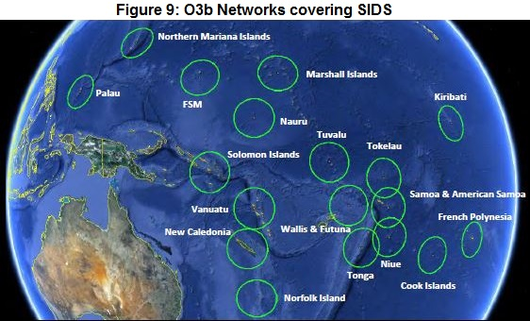

To meet the challenge of connecting the geographic dots across the Pacific Ocean, O3b Networks, a next generation medium Earth orbit satellite constellation has been launched on June 25, 2013. It combines the ubiquitous reach of satellite with the speed of fiber to deliver satellite Internet services and mobile backhaul services to emerging markets (Figure 9). The name "O3b" stands for "Other 3 Billion", referring to the population of the world where broadband Internet is not available without help.

Success of this cheaper satellite transmission system will largely depend on the wholesale IP transit prices across the hubs like Singapore and Hong Kong. According to TeleGeography, until Q2 of 2013, Fiji is the only country that has used terabit capacity (1.38 Tbps) of IP transit bandwidth while PNG and Samoa consumed 800 Mbps and 410 Mbps respectively. Therefore, the countries are unlikely to strike any bargain with the international carriers with such little capacity. Drastic reduction of wholesale bandwidth price by virtue of Asian Highway is the only hope of affordable broadband across SIDS in the Pacific Ocean.

5.6 TASIM – Trans-Eurasian Information Superhighway:

On December 21, 2009 the UN General Assembly unanimously adopted resolution (A/Res/64/186) entitled “Building connectivity through Trans - Eurasian Information Super Highway”. Aim of this project is to lay transnational optical fiber line covering the countries of Eurasia from Western Europe to Eastern Asia.

Furthermore, on December 21, 2012 the UN General Assembly adopted second resolution, which was supported by the UN Member states and was cosponsored by Afghanistan, Australia, Belarus, Canada, China, Georgia, India, Iraq, Israel, Japan, Kazakhstan, Kuwait, Lebanon, the Republic of Korea, the Republic of Moldova, Morocco, New Zealand, Pakistan, Russian Federation, Sri Lanka, Tanzania, Turkey, Ukraine, Uzbekistan, the United States.

On this range, discussions on “Improving Connectivity in Eurasia” were successfully organized within the framework of the establishment of the TASIM project component of the “Modernization of Sustainability and Efficiency of ICT infrastructure and ICT services in the Republic of Azerbaijan” Project during the 67th session of the United Nations General Assembly that was held at the UN Headquarters in New York on September 4, 2013. Initial members of the TASIM Consortium are state-owned incumbents as follows:

A memorandum of understanding regarding the implementation of the Trans-Eurasia Information Superhighway (TASIM) project has been signed in Baku, Azerbaijan in December 2013. Five operators representing members states of TASIM consortium: China Telecom (China), KazTransCom (Kazakhstan), Rostelecom (Russia), Turk Telekom (Turkey) and Azerbaijan’s Ministry of Communications and Information Technology were the signatories. The memorandum reportedly sets out the responsibilities of the operators, as well as financial liabilities and legal status.

7. Consider beyond the highway

7.1 Rail and Power infrastructure:

Optical fiber beneath the train track for railway signaling or along the power grid for SCADA have become the preferred long distance transport medium of telecommunication industry. Fiber networks for signaling and SCADA are the integral component of rail and power networks. Therefore, they do not represent significant share in the overall investments of railway or power transmission projects. Recent advancements in transmission technology have effectively blurred the differences between alternative and conventional long-haul fiber optic transmission networks.

The railway and electricity networks traverse by populated area. Neither railway signaling nor SCADA is bandwidth intensive application. Therefore, the rail and power entities inevitably end up with surplus capacity in respective fiber network. Such captive capacity allures the telecom providers, especially in the developing countries, for various practical reasons. Civil works, associated with trenching across the remote locations to deploy fiber, is a major incremental expense. Increasingly upward cost of transporting the materials at sites is also punishing. Unquantifiable payments for ‘right of way’ not necessarily guarantee access to the site.

These issues often disrupt the deadline and budget of telecommunication transmission projects. That’s why sharing cross-sector telecommunication infrastructure is paramount in achieving ubiquity of infrastructure as a key step to universal service provision. The model of sharing the alternative infrastructure, however, varies from country-to-country. Few examples are given bellow.

7.2 TransTeleCom (TTK), Russia:

TransTeleCom (TTK) of Russia operates the country’s largest optical fiber network along the rail line, which spans 75,000-km with a bandwidth of 1.5 Tbps. Its network spans from the western enclave of Kaliningrad by the Baltic Sea to Sakhalin Island at the North Pacific. In September 2007 TTK began rendering services on the long-distance and international telecommunications market.

Service portfolio of TTK includes national private lines, international private lines, Internet access, digital circuits, IP VPN, GPRS IP VPN, virtual Ethernet channel, local telephone services, long-distance and international telephone communications along with Certification center services.

It is one of three leading alternative operators of fixed communication and provides 33% of long-distance leased circuit. It has 27% market share in IP backbone and 31% in the IP VPN segments. TTK also operates fiber-to-the-home (FTTH) infrastructure covering an estimated 3.7 million Russian households. As of mid-February 2013, before the conclusion of the regional merger, TTK served approximately 1.1 million broadband subscribers.

7.3 RailTel Corporation of India Ltd.

RailTel Corporation is India’s one of the largest carrier-neutral telecom infrastructure providers. It has nationwide exclusive right of way to deploy OFC network along the 63,000 kilometers of railway track. Its 45,000 km OFC network presently connects over 4,500 townships and several rural habitats covering 70% of population. The network is supported by multiple of 10G/2.5G based STM-64/16 system rings.

RailTel also runs DWDM systems with 100G/400G capacity over 10,500 km of network. It will be further expanded to additional 14,000 km within 2014 to cover all major cities of the country. RailTel also has an MPLS network with core on 10G capacity along with NGN system to support various IP-enabled services.

RailTel offers a wide range of managed telecom services to Indian telecom market. The service includes managed lease lines, tower co-location, MPLS-based IP-VPN, Internet and NGN-based voice carriage services to telecom operators, Internet service providers, MSOs, enterprises, banks, government outfits, and educational institutions.

RailTel has deployed over 26 core links on 10G/2.5G capacity and 248 access links of 1G/100 Mbps capacity. Deployment of additional access and distribution links is in progress. It is also progressively entering into the enterprise solutions segment with special focus on government departments and educational institutions. Under the initiative, RailTel is creating data centers initially to provide data center and disaster recovery services to these customers.

RailTel has planned to launch various value-added services in the field of tele-presence, CDN, and a host of other network services for its enterprise customers. The company is upgrading its network infrastructure to provide high bandwidth capacities on 100G level. This infrastructure will support various broadband wireless access and 3G/4G service providers to deliver broadband nationwide including rural areas.

7.4 Power Grid Corporation of India Limited (PGCIL)

The optical fiber network of PGCIL covers 206 cities and towns with about 25,000 km of fiber network. Of this, optical ground wire (OPGW) comprises about 16,500 km and underground OFC links of about 8500 km. The company has an intra-city OFC network in 68 cities. It has regional telecom centers at Delhi, Mumbai, Kolkata, and Bengaluru and a National NOC at New Delhi.

Its network covers remote and far-flung areas including the Northeast and Jammu & Kashmir. The OPGW network of PGCIL offers domestic leg to the international long distance carriers for connecting India’s next-door neighbors like Bhutan, Nepal, and Bangladesh.

PGCIL is replacing ground wire with OPGW in some of the existing transmission lines. Main advantage of OPGW is inbuilt right of way, sturdy, secure, and reliable connectivity. Since there is no requirement for forest clearances, and OPGW installation is done live line without taking shut down on power transmission lines, faster rollouts are possible.

Currently, PGCIL is in the process of laying OPGW on various transmission lines under its load dispatch and communication schemes. Spare fibers on this network will also be available to expand its telecom network depending on demand from customers and can cover new cities and towns.

PGCIL's telecom network has multi-vendor equipment and is already upgrading capacity on its existing telecom network from 40 Gbps to 100 Gbps on major routes. PGCIL is further expanding its telecom network, including the addition of VAS like MPLS-VPN.

7.5 Asia meets Europe through MEETS: On September 30, 2013 - Vodafone’s Qatar unit, du of the United Arab Emirates (UAE) and Kuwait’s Zain along with the country’s ISP named Zajil have formed a consortium – Middle East-Europe Terrestrial System (MEETS). And optical power ground wire (OPGW) will be the vehicle during initial leg of its long distance terrestrial telecoms journey to Europe.

MEETS has rented 1,400-km OPGW from the power transmission grid of Gulf Cooperation Council’s (GCC) interconnection authority for 15 years. The consortium will invest US$36 million to primarily inject 2300 Gbps capacity using 100G optical transport networks (OTN) technology. It will dramatically increase the resilience of regional telecom backbone.

MEETS is an open cable system, which aims to make regional connectivity less expensive and more competitive and, at the same time, offer customers an improved data connectivity experience.

MEETS network will run from Kuwait to Fujairah (UAE) via Saudi Arabia, Bahrain and Qatar. Its final destination is Turkey via Iraq. The consortium is yet to disclose its mode of transport while crossing the highly challenging terrains of Iraq. OPGW across the diverse routes of Iraqi power transmission grid would be the safest option.

8. Policy recommendations for ITU

8.1 Promote open-access optical fiber network along Asian Highway: The terrestrial fiber optic links across Southeast Asia, notably the GMS network, are owned and operated by the dominant carriers. Their bandwidth capacity is low and the carriers are reluctant to give access to the competitors in the terrestrial networks. As a result, the third-party carriers are unable to offer any competitive bandwidth to the Internet Service Providers (ISPs). Therefore, deploying fiber along the Asian Highway will not achieve its goal unless the equitable access to this infrastructure is fundamentally guaranteed. The introduction of open access in Singapore and Hong Kong may be considered as role-models.

8.2 Persuade synergy between Asian Highway and TASIM: The proponents of TASIM are also the members of Asian Highway. Since highways are the long distance carriers’ preferred right-of-way, the TASIM network is expected to be deployed along the Asian Highway. Therefore, the Asian Highway members should explore the opportunity of getting integrated with the TASIM Consortium. It will enhance multilateral profile to TASIM initiative and the network will be expanded by manifolds. The United Nations General Assembly has endorsed the formation and functionalities of TASIM. Asian Highway, being fostered by another UN outfit, i.e., ESCAP, will greatly supplement each other.

8.3 Assessing the state of international transmission network: Outage has been a common phenomenon in the global infrastructure of Internet. Carriers, however, rarely disclose any such occurrence unless it is attributed to any natural disaster. And the regulators lack the tool to monitor such outage of networks as well. Such nondisclosure deceives the consumers. It also keeps the policymakers unaware of the fragility of national telecom networks. Therefore, it is necessary to assess the “health” of country-wise Internet to sensitize the policymakers about necessary reforms.

8.4 Assess the cost to build and operate a Eurasian terrestrial network: Assessing the capital expenditure as well as the operating cost of Eurasian telecom network is essential. It will provide clarity to the operators, vendors and lenders of this project. The modality of special-purpose vehicle, build-operate-transfer or outsourcing through management contract will depend on the budget.

8.5 Opportunities of using cross-sector telecoms infrastructure: Today’s transmission solutions have effectively blurred functional distinctions between a submarine and terrestrial network. The example of EPEG network, which is a combination of submarine and terrestrial cables, should prompt the policymakers to revisit their perception. Similarly, the 75,000-km. fiber network of Russia’s TransTeleCom (TTK) or the oil-rich Arab country’s proposed MEETS network demonstrate the futility of differentiating the potential of optical fiber in multi-sectoral operation.

Endnotes

“The State of Broadband 2013: Universalizing Broadband.” A report by the Broadband Commission, September 2013.
"Telecom Industry Fiber Optic Building Spree- Will It Lead to Another Fiber Glut?" Michael Weiss, April 3, 2012. Michael Weiss's blog.
“Submarine Telecoms Industry Report 2013.” Terabit Consulting. March 2013.
“Pan-European long-haul fiber demand increased 300%; operators to deploy 16.7 million fiber-km by 2002.” PR Newswire.
OECD Broadband Portal.
"Data Center Risk Index 2013." Cushman & Wakefield , May 17, 2013.
“Reforming Europe's Telecoms Regulation to Enable the Digital Single Market.” The Boston Consulting Group (BCG) for the European Telecommunications Network Operators’ Association (ETNO). July 19, 2013.
“U.S. No. 4 in LTE penetration survey.” RCR Wireless, September 25, 2013.
“The Global Information Technology Report Report 2013.” World Economic Forum. April 7, 2013.
TeleGeography's Global Internet Geography. Second Quarter, 2013.
“News Analysis: Broadband blueprint to facilitate China's economic restructuring.” Xinhua, August 19, 2013.
“International Sharing: Singapore’s Experience, GSR discussion paper, February 2008.” ITU.
“Legislative Council Paper No. CB(1)1289/09-10(04)”, March 8, 2010.
"Data Center Risk Index 2013." Cushman & Wakefield , May 17, 2013.
“Global Internet Geography – Asia.” TeleGeography. Q2 2013.
“Global Internet Geography IP Transit Pricing.” Q2 2013, TeleGeography.
Except Indonesia, Philippines and Singapore.
Internet Geography Q2 2013 edition, TeleGeography.
“An In-Depth Study on the Broadband Infrastructure in the ASEAN-9 Region.” Terabit Consulting, August 2013.
“An In-Depth Study on the Broadband Infrastructure in the ASEAN-9 Region.” Terabit Consulting, August 2013.
“Myanmar must restore its credibility along Internet.” Abu Saeed Khan, LIRNEasia. August 5, 2013.
“Myanmar Internet Disruptions.” Doug Madory, Renesys Corp. August 13, 2013.
“Using Global Content Balancing to Solve the Broadband Penetration Problem in the Developing World: Case Study, India.” Ashwin Gumaste, Prasad Gokhale, and Tamal Das, Indian Institute of Technology. M. K. Purohit and Peeyush Agrawal, Mahanagar Telephone Nigam Ltd. (MTNL). IEEE Communications Magazine. May 2012.
“Consultation Paper on Access Facilitation Charges and Co-location Charges at Cable Landing Stations.” TRAI, March 22, 2012.
“THE INTERNATIONAL TELECOMMUNICATION CABLE LANDING STATIONS ACCESS FACILITATION CHARGES AND CO-LOCATION CHARGES REGULATIONS, 2012 (No. 27 of 2012).” TRAI, December 21, 2012.
“Internet Infrastructure: Virtual meets Reality.” James Cowie, CTO, Renesys Corp., European Peering Forum, Reykjavik, Iceland. September 11, 2013.
“You’ve been cut, so what?” Infographic: Ciena GeoMesh, Ciena Corporation.
BBC, “Asia communications hit by quake”, December 27, 2006.
“Japan Quake.” Jim Cowie, Renesys Corporation. Mar 11, 2011.
“Japan quake hits cables, operators.” Melissa Chua. telecomasia.net, March 14, 2011.
“Saboteurs may have cut Mideast telecom cables: UN agency.” AFP. February 18, 2008.
“Egypt arrests as undersea internet cable cut off Alexandria.” BBC online. March 27, 2013.
Press release: “Fujitsu and NEC Complete Asia Submarine-cable Express (ASE)”. Fujitsu Limited and NEC Corporation. February 19, 2013.
“Asia’s Connectivity Patterns Shift as Carriers Become Less Dependent on U.S.” TeleGeography Insider. October 2013.
“Global Bandwidth Research Service Europe-Asia.” TeleGeography 2013.
“Will Iran Follow Sudan in Leaving the Internet?” Jim Cowie, Relesys Corp. September 26, 2013.
“Gulf States Turn to Iran, Russia for Internet.” Jim Cowie, Relesys Corp. April 22, 2013.
“Global telcos extend network connectivity with ‘Bay of Bengal Gateway’ system.” Moneylife, April 13, 2013.
“Europe emerges as global internet hub.” TeleGeography. September 18, 2013.
“Waves of change on the horizon in our optical industry.” Tom Mock, Ciena Corporation. June 10, 2013.
“Case Study - Korea: Opportunities for BB Connectivity in APAC.” Ki-young, Ko. September 24, 2013.
“UN recognition of the problems of land-locked developing countries.” UNCTAD website.
“Measuring the Information Society 2013, Table 2.1.” ITU, October 7, 2013.
“China Promotes Eurasia Network Integration.” Winston Qiu, Submarine Cable Networks, September 5 2013.
"2012 Internet access affordability in the Pacific Islands". Network Strategies.
“Fulfilling the Promise – Innovative Satellite Capacity for the Pacific's.” APT/ITU Pacific Forum 2013. Apia, Samoa. April 22, 2013.

